DRAFT
GRAND ISLE CEMETERY COMMISSION MEETING MINUTES
August 10, 2021, 3:30 p.m., Grand Isle Town Office

Meeting was called to order by Ilyo McCray, Chair, at 3:30 p.m.
Commissioners present: Lucille Campbell, Val Hunter, Sue Lawrence, Ilyo McCray
Commissioners absent: Jane Pomykala
Guests: none
Addition to the agenda: Resolutions to be signed authorizing Melissa Boutin to move money as voted by the Commission on May 11, 2021. Ilyo signed and gave both to Melissa.
Val moved to approve the minutes of June 8, 2021 and June 28, 2021. Sue seconded. Passed with all in favor.
Val reported that she had signed and sent in the contract with Champlain Monuments on July 14, 2021. We are waiting for a date when they will start the restoration/cleaning work.
Discussion of the proposal by Steve Plouff for the unmarked graves monument in the Grand Isle Cemetery. Consensus was that the design was not what we had discussed during his visit to the cemetery. Cornerstones are not needed and the inscription was not suitable. Lucille presented several other ideas. The consensus was for a dark stone, slant design at least 24” by 36” on a matching base and installed. It is to be located on the south-west side of the old section of the cemetery. The inscription should read: “This memorial is dedicated to those resting in unmarked graves on these grounds. Grand Isle Cemetery Commission 2021”. (Proposed design attached to minutes)
Sue moved that we do not go with Steve Plouff’s original design and that we send him a computer rendition of what we would like to have, and see what his estimate would be. Val seconded. All in favor.
Lucille will contact Jane with the new design and see if she will get in touch with Steve Plouff again.
Sue gave the Commissioners the new cemetery email address and password from Chuck Holton.
The FY 2020-21 end of year financial report from Melissa was discussed. We confirmed that the restoration expenditures do not need to be broken out for individual cemeteries, contract labor will be only for lawn care, caretaker and administration expenditures will be separate line items. Revenues for FY 2020-21, including the Town appropriation of $24,000, lot sales, interest/dividends, Russell, Hanson and Trust Funds totaled $41,719.90. Total expenditures were $20,072.08. Total fund balance including Trust Fund, CDs, stocks, and Money Market is $232,486.07.
Brief, general discussion of budget for FY 2022-23. The town appropriation should be for lawn care and the surplus be used for restoration, labor to raise cornerstones, filling low spots, fence, etc.
Sus reported that many cremation interments and burials have happened in the last month or two.
No lawn care bill has been submitted yet for this current fiscal year.
There was a concern from a member of the public about a missing cornerstone. Sue and Val will check.
Sue moved to adjourn, Lucille seconded, passed. Meeting adjourned at 4:40 p.m.
Next meeting Sept. 14, 2021 at 3:30 p.m.
Respectfully submitted,
Lucille Campbell, Recording Secretary

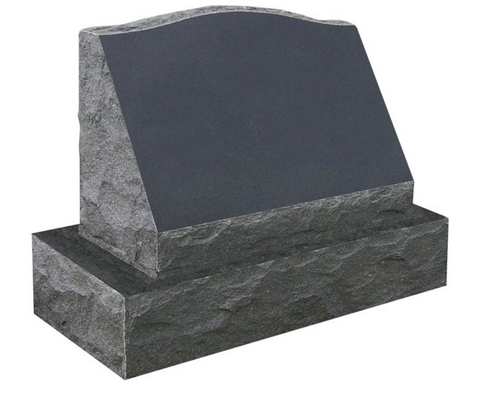
This monument is dedicated to those resting in unmarked graves on these grounds.

Grand Isle Cemetery Commission
2021

Proposed design for unmarked graves monument suggested by Grand Isle Cemetery Commissioners, Aug 10, 2021. To be installed on south-west side of old section of Grand Isle Cemetery. Dark granite at least 24” wide and on a base.

Slant on Base common sizes
- Single grave. One name. 24” x 10” x 16” (Slant on Base. 34” x 14” x 6”)
- Single grave. Two names. 30” x 10” x 16” (Slant on Base. 40” x 14” x 6”)
- Double grave. Two names. 36” x 10” x 16” (Slant on Base. 48” x 14” x 6”) Can be larger depending on amount of artwork.
- Infant marker. 20” x 10” x 16” (Slant on Base. 30” x 14” x 6”)
http://pattenmonument.com/knowledge-center/5-steps-to-selecting-a-monument/step-2-size/

